Import Sending Branch Transfer Workflow Functional Document

Application | NGERP - Centra
Workflow | Store To Shelf
Workflow Item Name | Import Sending Branch Transfer

Description:

Sending a branch transfer in ERP involves initiating the movement of inventory or goods from one branch to another, ensuring accurate stock records across locations. This process typically includes generating transfer orders, updating inventory, and tracking the shipment status within the ERP system.

Workflow Process:

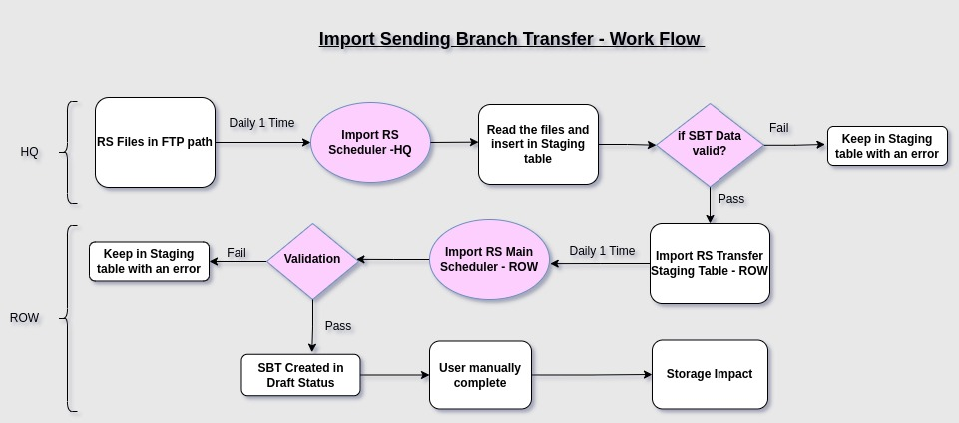

Business Rules:

- Import is purely for SBT creation details to be received from the specific path.
- The files are located at a specific path: /MLD/EDI/NGERP/WIP..
- Verify whether the Order Type field is denoted by ‘AL’ create Branch Transfer
- The scheduler will enable and read the file 1 time per day.
- When the Import Recommended Shipment Scheduler is running, read the date and insert it into the temporary table (UM_I_RecommendedShip).
- Then Import Recommended Shipment Scheduler Main is running, read the date into Import RS – Transfer screen and validate the date.
- Warehouse, Product code, Region validation.
- Date Should be greater than current date.
- If the data is valid, the records are inserted into the main table. Otherwise, they are
- retained in the temporary table, and an appropriate error message is generated.
- The files in the designated folder start with the prefix 'RECSHPIB_V01.
- The files must be in .txt format.
- The files should contain a total of 18 columns.

